

West Australian Test Papers

PHYSICS

Year 11

2004

SOLUTION BOOKLET

&

MARKING GUIDE

Markers should note that the solutions presented here are skeletal answers and
should be used as a guide only.

Alternate answers used by students may be perfectly acceptable and discretion
should be used.
Section A

1 momentum west = p = m v = 60 x10⁻³ x 15.0 = 9 x 10⁻¹ kg m s⁻¹
momentum east = p = m v = 60 x 10⁻³ x 15 = 9 x 10⁻¹ kg m s⁻¹

Change in momentum = p _{final} = p _{initial} = ( 9 x 10⁻¹ east - 9 x 10⁻¹ west)

= 1.8 kg m s⁻¹ east

2a v² = u² + 2 a s
v² = 0 + 2 x 9.8 x 1.5

v = 5.422 m s⁻¹

Momentum = p = m v = 0.058 x 5.422 = 0.31 kg m s⁻¹

2b If the time of impact is increased then the force on the egg is reduced. This is due to

F = change in momentum.
time

3a (i) The decay line of the graph is not smooth. This indicates that the decay is a random process. The decay is distributed about a general decay trend.

3a (ii) The two graphs are identical. This would indicate that the decay rate is independent of
temperature.

3b The film badge would contain various materials (paper, aluminium, lead) that would shield against the different types of radiations. Beta radiation would penetrate the paper barrier but not the other barriers. When the film was exposed it would indicate the part of the film covered by the paper would be exposed but the rest of the film would be unexposed.

4a P = V² / R

1.2 x 10³ = 240² / R

R = 240² / 1200 = 48.0 Ω

4b Two factors that could affect the resistance of the nichrome wire include length of the wire, diameter of the wire and temperature of the wire.

- Work done = energy expended = m g h
= 1.3 x 10⁹ x 9.8 x 2.0

power = work done / time

power = (1.3 x 10⁹ x 9.8 x 2.0) / 24 x 3 600

power = 2.95 x 10⁵ W

- Dose equivalent = absorbed dose x quality factor

(8 x 10⁻³ x 20) + (32 x 10⁻³ x 1) = 0.16 + 0.032 = 0.192 Sv

for 25 days the dose equivalent would be 4.8 Sv

- The specific heat of the filling of the pie is grater than the pastry. The filling and the pastry are at the same temperature but the heat content of the filling is greater than the pastry so it seems hotter.

8 ²¹⁰ Bi ₈₃ ----→ ²¹⁰ Po ₈₄ + º e ₋₁

²¹⁰ Po ₈₄ -----→ ²⁰⁶ Pb ₈₂ + ⁴ He ₂

9a A convex mirror can be used as a rear vision mirror or a security mirror.

9b Chromatic aberration occurs when light is incident on a lens and the colours that make up the light are dispersed at different angles by the lens. The colours come to different foci causing a coloured fringe.
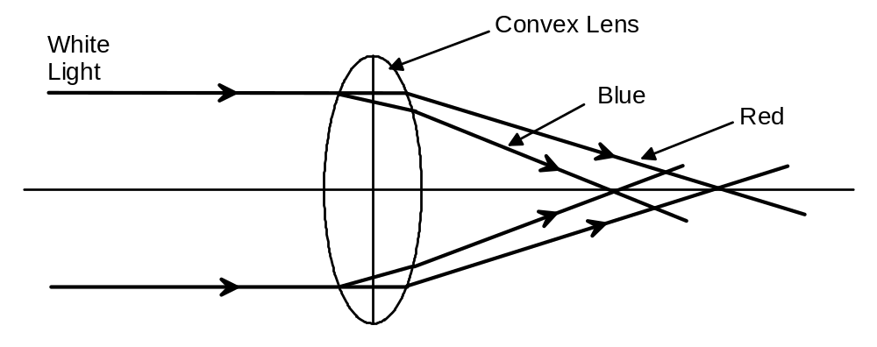

10a Force is 220 x 9.8 x sin 23º = 842 N

10b The total force is the force exerted plus the frictional force = 842 + 65 = 907 N

- The translucent cover protects the light but its main function is to diffuse the light so the light is spread evenly over a larger area. A more even illumination is produced.

12a The maximum speed is attained when the gradient is at its steepest
(AB) = 2 / 0.5 = 4.0 m s⁻¹

12b (i) The train is stationary for 1.5 s

12b (ii) The train is travelling backwards to its original position at a velocity of 2 m s⁻¹

12c The length of track can be calculated by the area under the curve. = 10.5 m

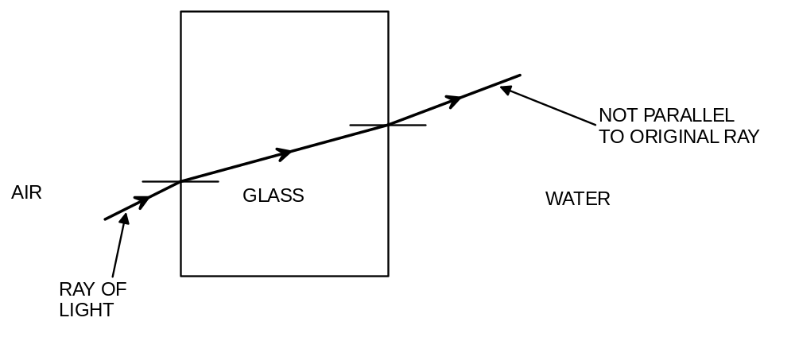13a

13b Velocity – As the light travels from air to glass the velocity decreases
Frequency – Remains the same
Wavelength – decreases

14a Q = m c ΔT

Q = 200.0 x 4 180 (25 - 15)
= 8.36 x 10⁶ J

14b power = energy / time = 8.36 x 10⁶ / (3 x 3600) x 1000

= 0.77 kW

15a The electric field at ‘X’ will be in the direction of D.

15b If a positive test charge is placed at X it will be repelled by K in the direction of B. and attracted to L. The force on the test charge will be greater in the direction of L than the repulsion in the direction of B. Therefore the resultant direction of the field will be in the direction of D

Section B

1a Heat lost by the steam

(m c ΔT ) + ( m L ) + ( m c ΔT)

{m x 2 000 x (110 -100)} + (m x 2.25 x 10⁶) + {m x 4 120 x (100 – 80)}
= m (21 000) + ( 2.25 x 10⁶) + (84 000)
= m x (2.354 x 10⁶)

Heat gained by the water

m c ΔT
0.2 x 4180 x (80 – 20) = 50 160 J

Heat gained by the glass
0.25 x 837 x (80 – 20) = 12 555 J

Assume Heat gained by water and glass = Heat lost by steam
50 160 + 12 555 = m x (2.355 x 10⁶)

Mass of steam = increase in mass of water = 62 715 / 2.355 x 10⁶

= 26.6 g

1b Statement D is correct.

1c The experiment demonstrates that the conductivity of copper is greater than the conductivity of aluminium.

2a Statement C is correct.

2b (i) the value of ‘X’ is 4

2b (ii) Total mass on left hand side of equation:
= 236.05119 u

Total mass on right hand side of equation = 136.87688 + 94.19481 + (4 x 1.008665)
= 235.10635 u

Mass defect = 236.05119 - 235.10635 = 0.94484 u
= 931 x 0.94484 = 879 .64 MeV
=879.64 x 1.6 x 10⁻¹³ = 1.4 x 10⁻¹⁰ J

2b (iii) They are travelling with kinetic energy = 0.5 m v² = 1.4 x 10⁻¹⁰ J
v² = 2 x (1.4 x 10⁻¹⁰) / 4 x (1.675 x 10⁻²⁷)
v = 2.04 x 10⁸ m s⁻¹

2c (i) Beta is chosen for this application because depending on the thickness of the paper the beta radiation will penetrate it. If the paper becomes too thick the radiation will not penetrate and the rollers will be adjusted to reduce the thickness. Alpha radiation is not suitable because it will not penetrate any thickness of paper. Gamma is unsuitable because it penetrates all thicknesses of paper.

2c (ii) The count is reducing indicating less beta radiation is being detected therefore the paper must be getting thicker.

2c (iii) 1 500 750 375 187
5.50 y 11.0 y 16.5 y

The sample will be useful between about 12 and 14 years.

3a (i) n₁ x sin θ₁ = n₂ x sin θ₂
1.52 x sin 60º = n x sin 90º

refractive index of the liquid is 1.316

n = 2.25 – 0.025
1.136 = 2.25 - 0.025 T

Temperature of liquid ‘X’ is = 37.3 º C

3a (ii) When T = 20º then n = 1.75
n₁ x sin θ₁ = n₂ x sin θ₂
1.52 x sin 60º = 1.75 x sin θ₂
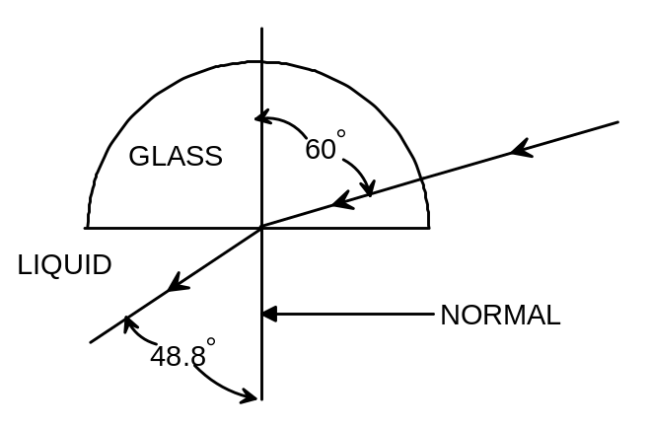 θ = 48.8^{ο}

3a (iii) 1.75 = speed of light in vacuum / speed of light in liquid X

  - = 3 x 10⁸ / speed in X

speed in liquid x = 1.71 x 10⁸ m s⁻¹

3a (iv) When T = 50º
then n = 2.25 - (0.025 x 50) = 1

When T = 37º then n = 1.31

The refractive index will decrease to be equal to 1.0 when the angle of incidence is 50º. It will be totally internally reflected at this (50º) angle of incidence. The liquid will have a refractive index of 1.31 at 37º and this will be the critical angle.

4a F = m a
12 500 = 1 250 x a
acceleration = 10 m s⁻²

v² = u² + 2 a s
0² = u² + 2 x (-10) x 50
u² = 1000
u = 31.6 m s⁻¹

4b 31.6 m s⁻¹ = 31.6 x 3 600 / 1 000 = 114 km h⁻¹
Yes, the car is travelling at over twice the speed limit

4c v = u + a t
0 = 31.6 + (-10) x t

t = 3.2 s

5a Consider lamp X
P = V x I
24 = 12 x I
I = 2 A

And resistance is 6 Ω

Consider lamp Y
P = V x I
18 = 6 x I
I = 3 A

And resistance is 2 Ω

5b (i) 12 V

- V = I x R
  - = 3 x R
R = 2 Ω

- 5 A

- 27 - 12 = 15 V

- V = I x R

- = 5 x R
R = 3 Ω

- V = I x R
12 = 2 x R
R = 12 / 2 = 6 Ω

V = I x R
12 = 3 x R
R = 12 / 3 = 4 Ω

Parallel resistance !/6 + 1/4 = 5 / 12 so resistance is 12/5 = 2.4 Ω

- Heat generated is equivalent to the energy dissipated = V x I x t

= 27 x 5 x (5 x 60) = 4.05 x 10⁴ J

6a PE = m g h = 505.0 x 9.8 x 31 = 1.53 x 10⁵ J

6b 1.53 x 10⁵ = ½ 505.0 x v² + (30 x 70)

1.53 x 10⁵ = 252.5 x v² + 2 100

v² = (1.53 x 10⁵ - 2 100) / 252.5

v = 24.4 m s⁻¹

6c momentum = m x v = 505 x 24.4 = 1.23 x 10⁴ kg m s⁻¹

6d For the ride to continue under the influence of gravity, the height of the ride can never be higher than the starting height. The potential energy at the starting point is the maximum energy the ride acquires and this can not be exceeded if the ride has no other input of energy.

6e KE = PE
0.5 m v² = mgh
0.5 x (24.4) ² = 9.8 x h
h = 30.4 m

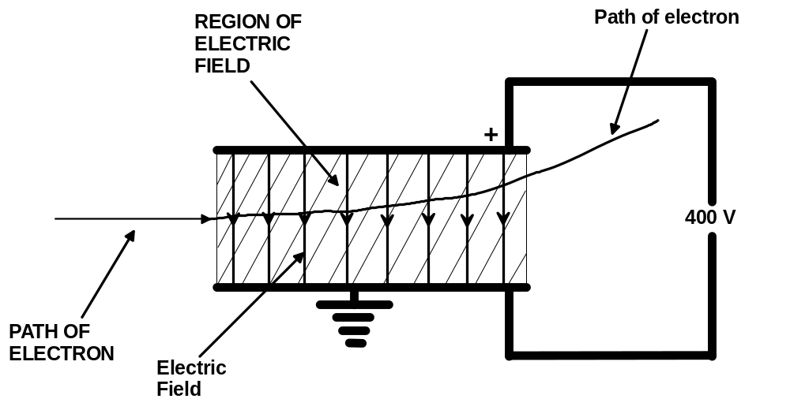7a

7b(i) See the diagram above. (answers to 7a and 7b(i) both on same diagram

7b(ii) E = q x V
E = 1.6 x 10⁻¹⁹ x 400
E = 6.40 x 10⁻¹⁷ J

7c F = m a
8 x 10⁻¹⁵ = 9.11 x 10⁻³¹ x a
a = 8 x 10⁻¹⁵ / 9.11 x 10⁻³¹
a = 8.8 x 10¹⁵ m s⁻²

7d The acceleration will change. The medium through which the particle travels influences the force that is applied to the particle. The accelerating force on the electron is likely to be less in air than in a vacuum therefore the acceleration will be less.

7e 90% of the speed of light is 0.9 x 3 x 10⁸
= 2.7 x 10⁸ m s⁻¹
momentum = m x v
= 9.11 x 10⁻³¹ x 2.7 x 10⁸ = 2.46 x 10⁻²² kg m s⁻¹

7f Momentum is a vector quantity. Because it has changed direction its momentum will have changed.

Section C

Question 1 - Solar Electricity

- Diffuse in this context means the energy is spread over a wide area compared to a concentrated beam of energy.

- 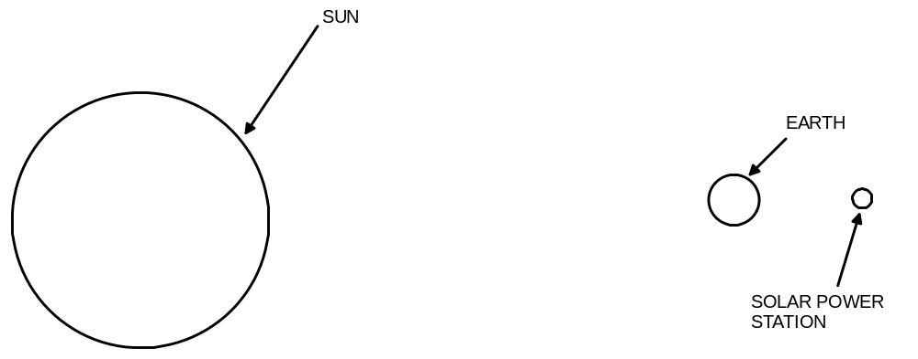Weather problems would consist of cloud cover obstructing the sun’s radiation reaching the collectors. As the collectors are beyond the troposphere the likely hood of cloud is reduced.

3

4 The function of the transmitting antenna is to transmit the collected energy via microwaves to the receiving antenna on the earth.

5 The power station needs to be in an orbit (geostationary) so it will always be above the receiving antenna on the earth. It can then transfer the energy continuously to the earth.

6 Power output per square metre = 9.50 x 10⁹ / (5.9 x 10³ x 4.9 x 10³)

= 3.3 x 10² W m⁻²

7 This statement means that the cost of providing the energy to build the power station in the first place could be recouped in about three years due to the savings it would produce compared to generating conventional power in the meantime.

8 The solar power station will produce more energy in a 24 hour period.

Power = energy / time

For the conventional power station:

1.5 x 10³ = E / (24 x 60 x 60)

Energy = (1.5 x 10³) x (24 x 60 x 60) = 1.3 x 10² MJ

For solar power station

5 x 10³ = E / (24 x 60 x 60)

Energy = (5 x 10³) x (24 x 60 x 60) = 4.3 x 10² MJ

9 The solar station would be closer to the sun. This would account for a marginal increase in solar energy being absorbed by the solar station. Also, closer to the earth there would be more solar radiation being absorbed by the atmosphere so less radiation reaches the earth’s surface.

Question 2 - Fission and Fusion Bombs

1 ³H₁ + ²H₁ ⁴He₂ + ¹n_{o}

2 1 / 27.8 x 10⁻¹³ = 3.59 x 10¹¹ reactions

3 Fusion reactions often involve deuterium and tritium. Deuterium and tritium are isotopes of hydrogen

4 A fusion bomb requires a very large quantity of energy to react it. This energy can be supplied by a fission reaction. Therefore the fission bomb was developed first.

5 Sr 90 in milk can have serious side effects for children. It has properties similar to calcium so it may accumulate in the bones.

6 Radiation from a bomb affects many nearby materials by irradiating them with neutrons.

7 120 years

8 Only gamma radiation is not absorbed by air. All other types of radiation is dissipated in the atmosphere and in some cases carried from the reaction site by winds.

9 Developing a ‘vessel’ in which to react gases at high temperatures and high densities. Achieving the density of gas and the temperature of the gas have restricted development.

- DE = AD x QF

10 = AD x 20

Absorbed dose = 10 / 20 = 0.5 Gy

